The Researcher Development Framework (RDF)

In September 2010 Vitae (www.vitae.ac.uk) launched the national Researcher Development Framework (RDF). The RDF is designed to help empower you as a researcher and engage you in effective personal and professional development planning. By being more aware of your skills and having a plan for future development it will help you to make the right choices at the right times in your career.

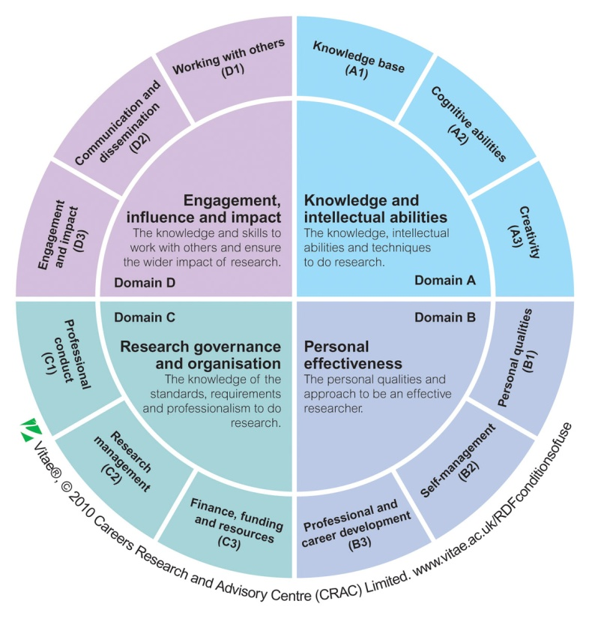
The RDF (www.vitae.ac.uk/rdf) describes the knowledge, behaviours and attitudes of researchers at all stages of development from first year postgraduate researchers through to high profile research leaders. It has been developed from first principles through interviews with successful researchers in a range of disciplines and is fully endorsed by Research Councils UK.

What does the RDF look like?
The RDF is structured in four domains (A-D), which encompass what researchers need to know to do research, how to be effective in their approach to research, when working with others and in contributing to the wider environment. The domains are further divided into sub-domains (e.g. A1, A2 and A3), each with descriptors and phases (1-5; representing a progressively higher level of skills in that area) which seek to capture the knowledge, behaviours, and attitudes of a typically ‘good’ researcher at different stages of development.

How to use the RDF
You might want to use the RDF as an extension to the Postgraduate Skills Record to help you to:
• prepare for one-on-one reviews with your supervisor, where you will be discussing your professional or career development;
• identify strengths and areas to focus on;
• prioritise the most appropriate formal and informal development opportunities provided by your institution and/or external bodies;
• consider skills and experiences that will enhance your prospects of success in particular career areas.

Vitae have also launched a Professional Development Planner to help you map yourself against the RDF. This self reflection tool is available from www.vitae.ac.uk/rdfplanner.
It currently uses Microsoft Excel and allows you to:
• select which areas of the RDF you are interested in;
• record where you are currently and what your next target for development is;
• record evidence of your current skills and experience;
• complete an action plan to reach your target;
• save individual versions at different time points to track your own progress.

For more information or if you have any feedback or ideas for future developments using the RDF, visit www.vitae.ac.uk/rdf or contact rdf@vitae.ac.uk

